Section A: Google Sheet
Google Sheet Link:
https://docs.google.com/spreadsheets/d/1l4BmBHUQGKc2aRhNeDxZm6AuJQ0WNWr5Mxv2kgNhBBM/edit?usp=sharing
Total sales amount by date
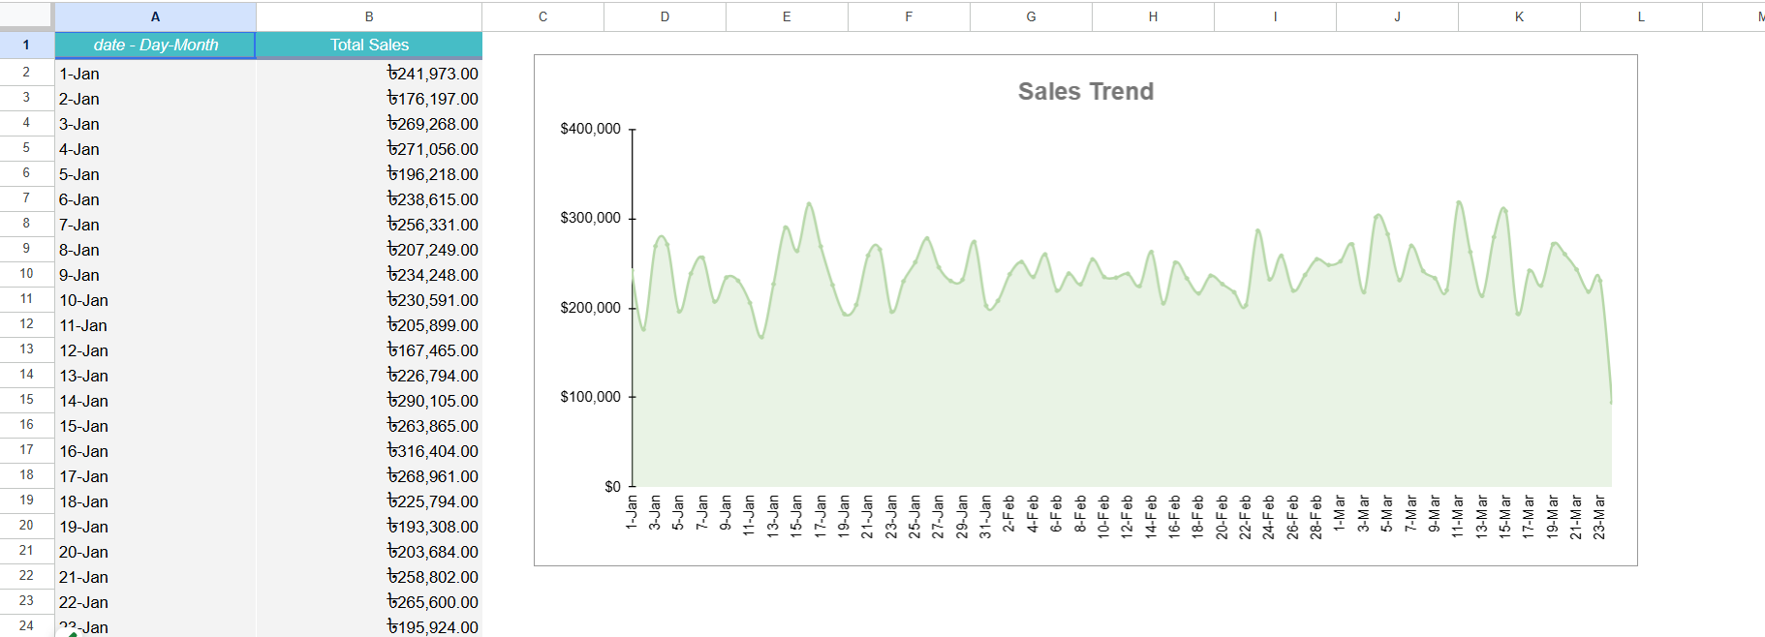
Total sales amount by shop type
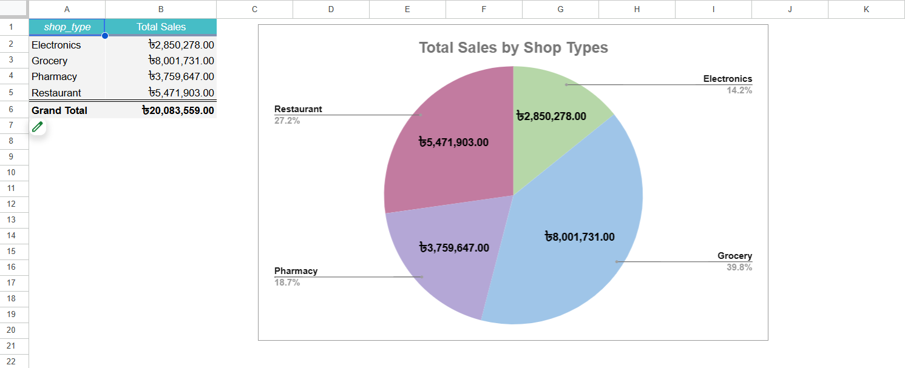

Average transactions per shop
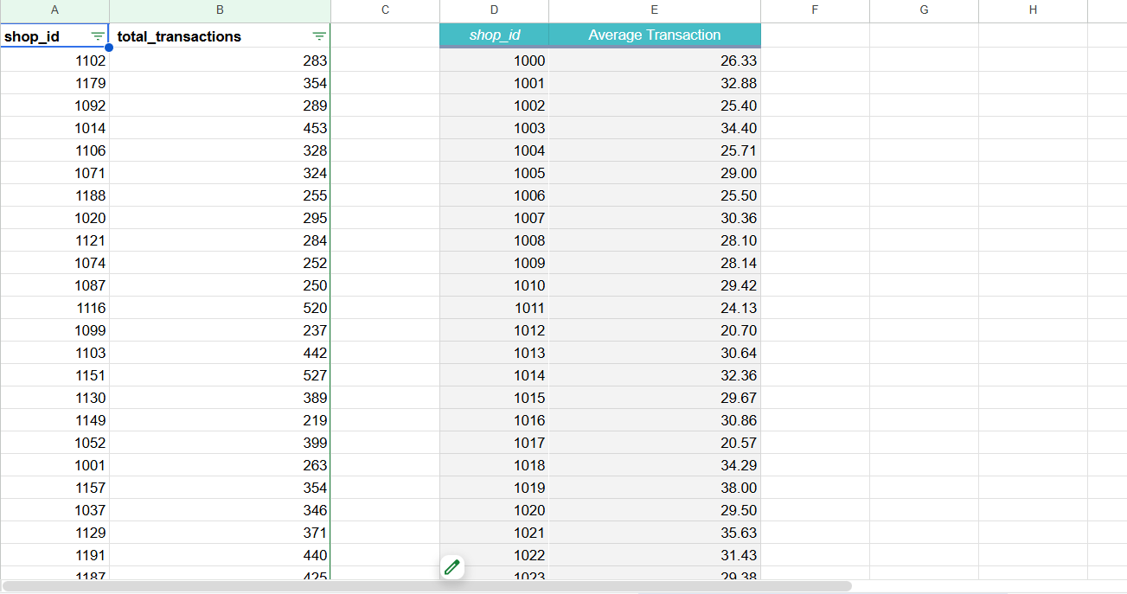
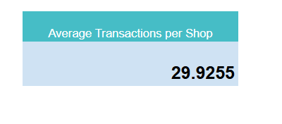
Sales amount by city
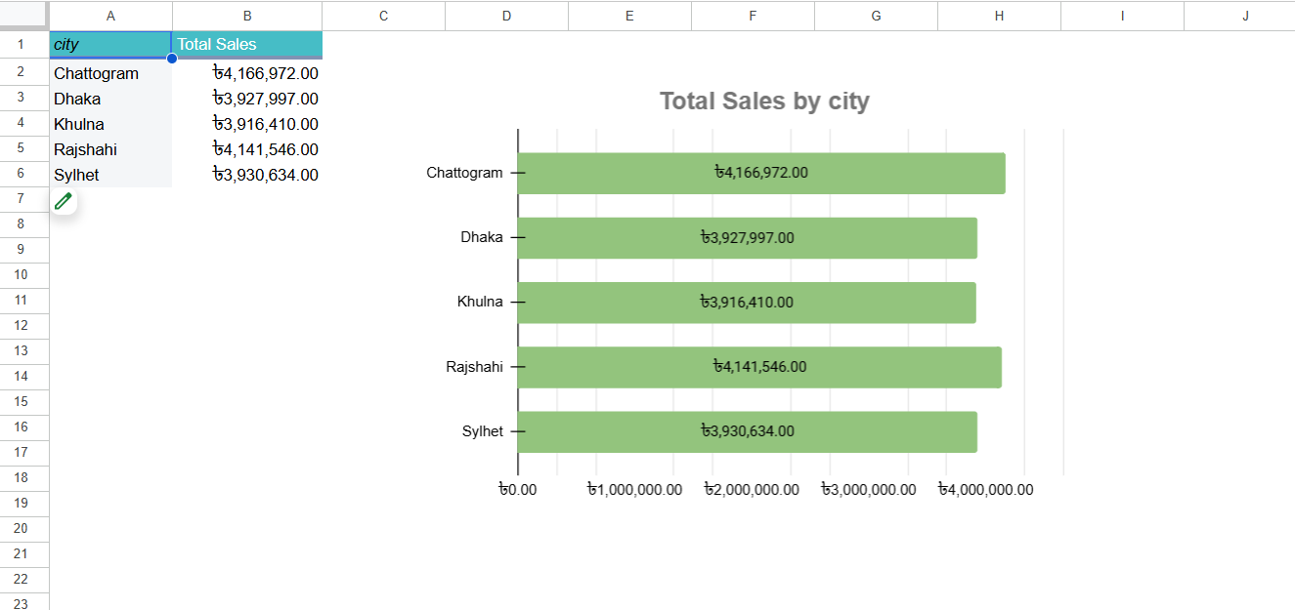
Subscription purchased count by shop type
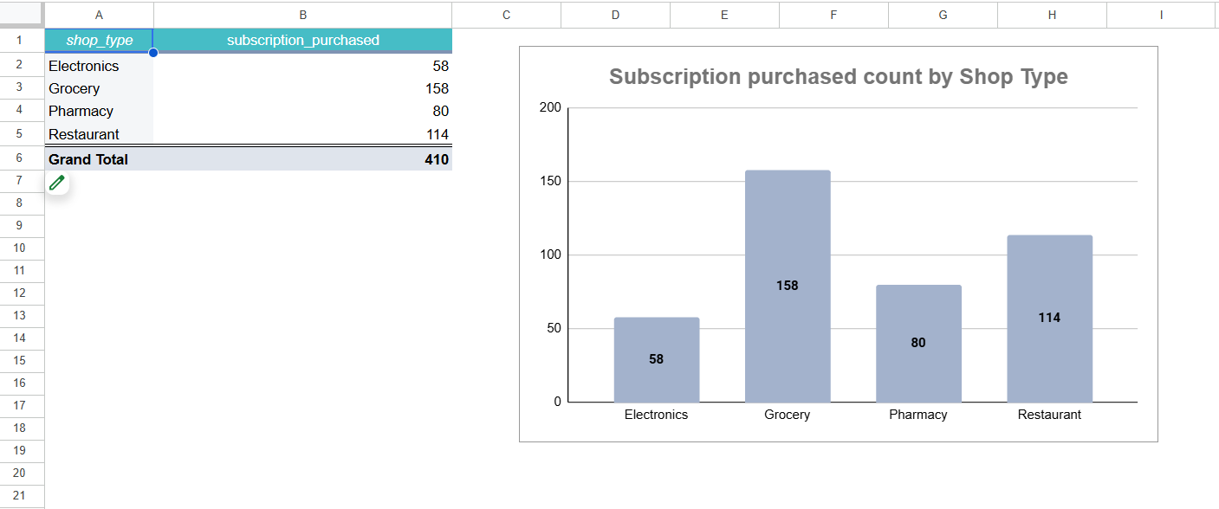

Section B: SQL
Q1. Daily Performance Classification
MySql Script:
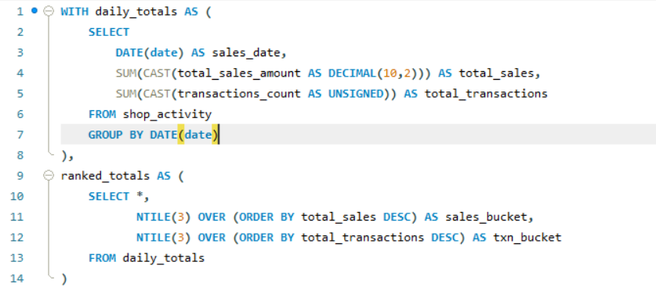
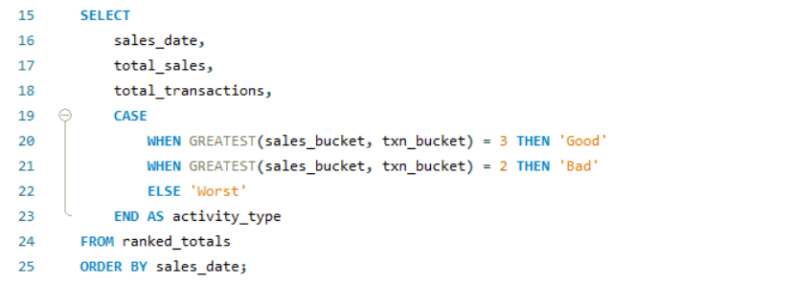
Output:
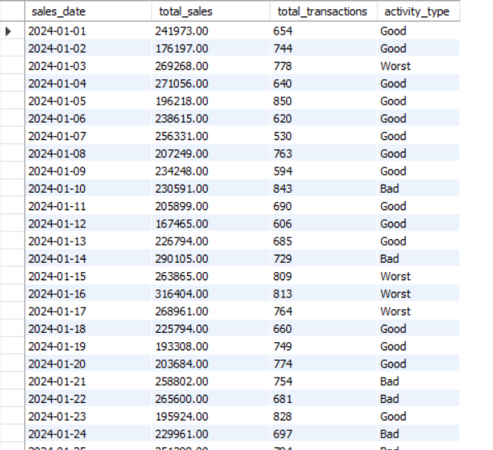

Q2. New vs Existing User Analysis
MySql Script:
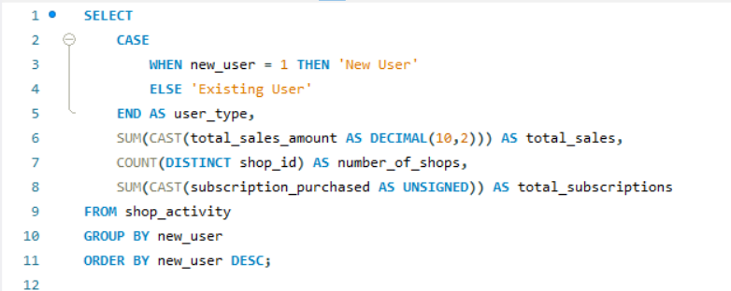
Output:
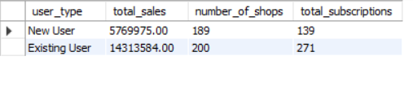
Q3. Subscription Conversion by Shop Type
MySql Script:
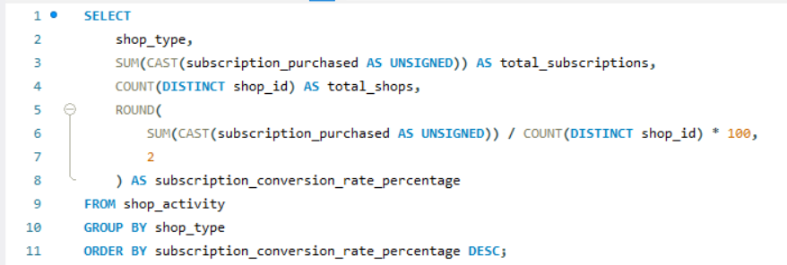
Output:
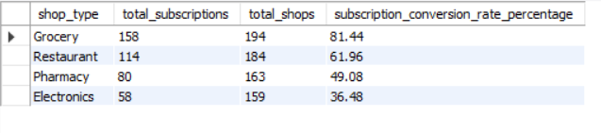
Q4. City Performance
MySql Script:
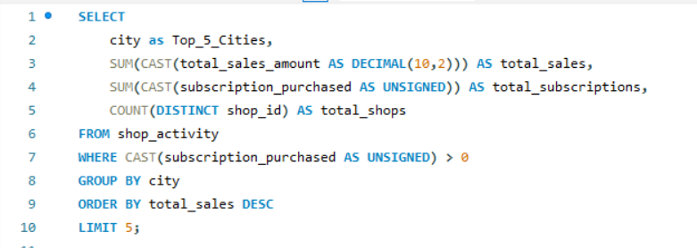
Output:
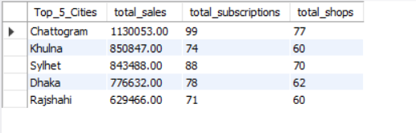

Section C: Business Insights
- Which shop type appears to be the most valuable for the business? Why?
Answer:
Based on the subscription conversion analysis and total sales data, Grocery shops appear to be the most valuable for the business. They not only generate the highest total sales (৳8,001,731) but also show a strong subscription adoption rate (81.44) compared to other shop types. This combination of high revenue and higher subscription conversion indicates that Grocery shops are a stable and profitable segment, making them a key focus for business growth.

- Do new users or existing users contribute more to total sales? What does this imply?
Answer:
The analysis of new versus existing users shows that existing users contribute more to total sales (৳1,43,13,584) than new users. While new users provide additional revenue, existing users demonstrate higher repeat purchase behavior and are more likely to purchase subscriptions. This implies that customer retention is crucial for sustaining revenue, and initiatives such as loyalty programs or personalized offers could further increase sales from the existing user base.

- Suggest one business or product improvement based on the data.
Answer:
Focus on high-performing shop types and retain existing users to maximize revenue. Use data-driven promotions to improve subscription conversion in lower-performing segments.

